Q1. Create database springDemo with user table with fields
(a) username
(b) password
(c) name
(d) age
(e) dob

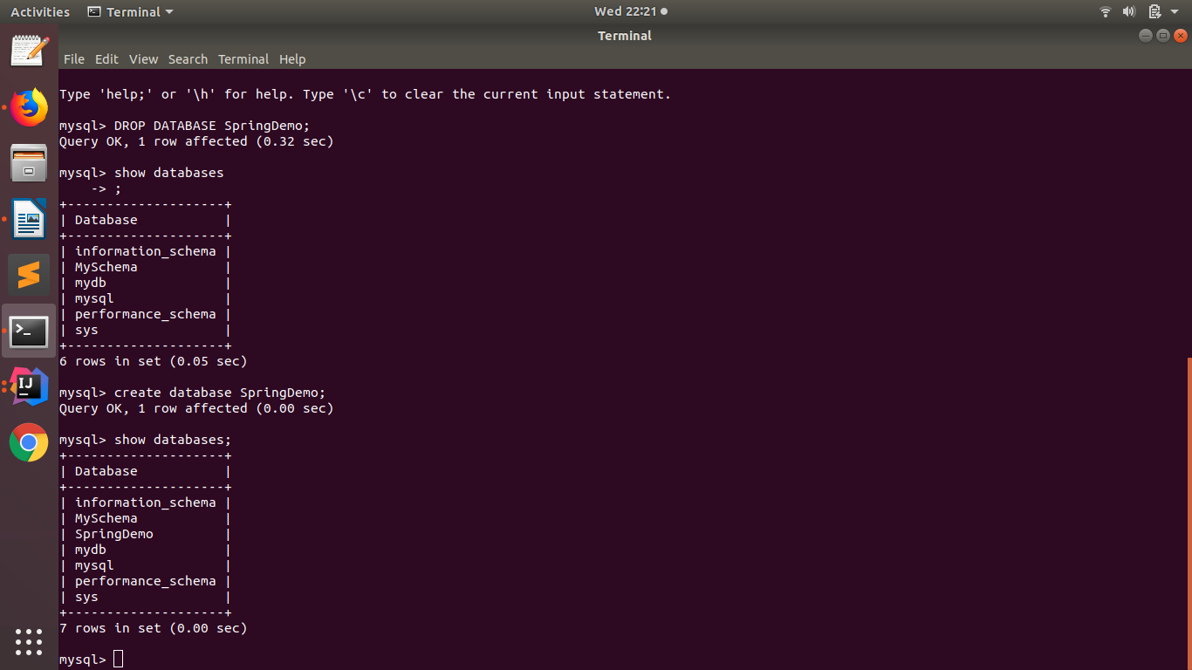
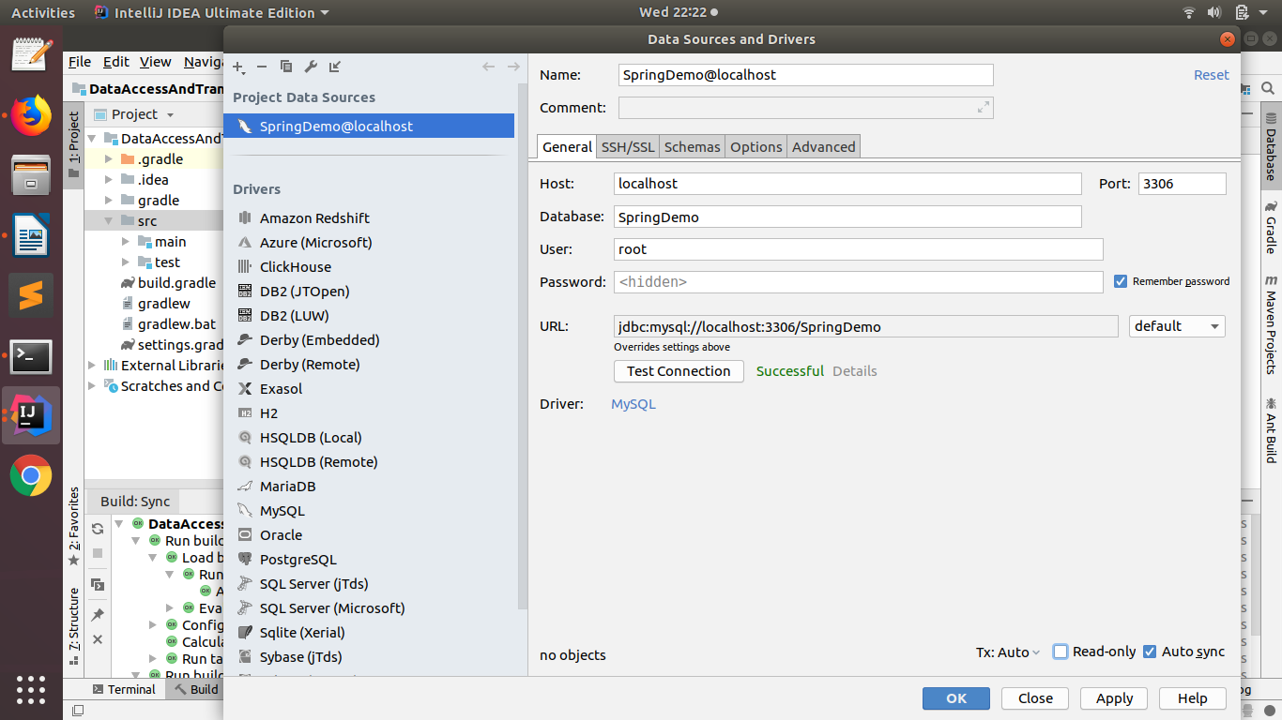

package com.data;
import java.sql.*;

public class Question1 {

private static final String JDBC_DRIVER = "com.mysql.jdbc.Driver";
private static final String DB_URL = "jdbc:mysql://localhost:3306/SpringDemo";
private static final String USER = "root";
private static final String PASS = "K96sanjeev@";

public static void main(String[] args) throws ClassNotFoundException, SQLException {

Connection conn = null;
Class.forName(JDBC_DRIVER);
System.out.println("Connecting to a selected database...");
conn = DriverManager.getConnection(DB_URL, USER, PASS);
System.out.println("Connected database successfully...");
System.out.println("Creating table in given database...");

String sql = "CREATE TABLE USER " +
"( id INT NOT NULL AUTO_INCREMENT, " +
" username VARCHAR(25) UNIQUE , " +
" password VARCHAR(25), " +
"name VARCHAR(25), " +
"dob DATE , " +
" age INTEGER(5), " +
" PRIMARY KEY ( id ))";

PreparedStatement preparedStatement = conn.prepareStatement(sql);
preparedStatement.execute();
System.out.println("Created table in given database...");
}
}

config.xml

<context:component-scan base-package="com.data"/>

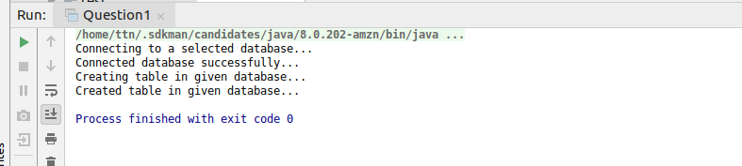

Q2. Insert few records inside user Tables

package com.data;
import java.sql.Connection;
import java.sql.DriverManager;
import java.sql.PreparedStatement;
import java.sql.SQLException;

public class Question2 {

private static final String JDBC_DRIVER = "com.mysql.jdbc.Driver";
private static final String DB_URL = "jdbc:mysql://localhost:3306/SpringDemo";
private static final String USER = "root";
private static final String PASS = "K96sanjeev@";

public static void main(String[] args) throws ClassNotFoundException, SQLException {

Connection conn = null;
Class.forName(JDBC_DRIVER);
System.out.println("Connecting to a selected database...");
conn = DriverManager.getConnection(DB_URL, USER, PASS);
System.out.println("Connected database successfully...");
System.out.println("Inserting data...");
String query = "INSERT INTO USER (username, password, name, dob, age) values " +
"('rohanttn', 'rohan12', 'Roahan', '1990-02-12' ,28), " +
"('abhinavttn', 'abhinav26', 'Abhinav', '1993-08-26', 25)";
PreparedStatement preparedStatement = conn.prepareStatement(query);
preparedStatement.execute();
System.out.println("Inserted data...");
conn.close();
}
}

config.xml

<context:component-scan base-package="com.data"/>
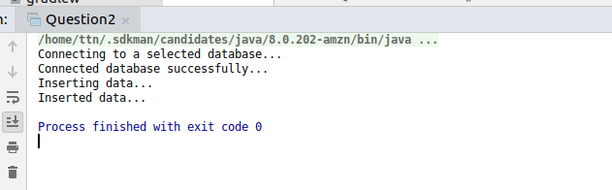
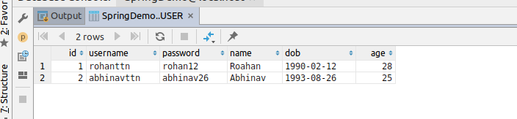

Q3. Use datasource with DriverManagerDataSource, dbcp2.BasicDataSource and SingleConnectionDataSource to print the records of user tables

package com.data;
import org.apache.commons.dbcp2.BasicDataSource;
import org.springframework.beans.factory.annotation.Autowired;
import org.springframework.context.ApplicationContext;
import org.springframework.context.support.ClassPathXmlApplicationContext;
import org.springframework.jdbc.datasource.DriverManagerDataSource;
import org.springframework.jdbc.datasource.SingleConnectionDataSource;
import org.springframework.stereotype.Component;
import java.sql.Connection;
import java.sql.PreparedStatement;
import java.sql.ResultSet;
import java.sql.SQLException;

public class Question3 {

public static void main(String[] args) throws SQLException {

ApplicationContext ctx = new ClassPathXmlApplicationContext("config.xml");
DriverManagerDataSourceConnection driverManagerDataSourceConnection = ctx.getBean(DriverManagerDataSourceConnection.class);
driverManagerDataSourceConnection.displayRecord();
BasicDataSourceConnection basicDataSourceConnection = ctx.getBean(BasicDataSourceConnection.class);
basicDataSourceConnection.displayRecord();
SingleConnectionDataSourceConnection singleConnectionDataSourceConnection = ctx.getBean(SingleConnectionDataSourceConnection.class);
singleConnectionDataSourceConnection.displayRecord();
}
}

@Repository
class DriverManagerDataSourceConnection {

@Autowired
private DriverManagerDataSource driverManagerDataSource;

void displayRecord() throws SQLException {

Connection connection = driverManagerDataSource.getConnection();
PreparedStatement preparedStatement = connection.prepareStatement("SELECT * FROM USER");
ResultSet resultSet = preparedStatement.executeQuery();
System.out.println("Reading data using DriverManagerDataSource...");
System.out.println("username\tpassword\tname\tdob\t\tage\n--------------------------------------------------------");
while (resultSet.next()) {
System.out.println(resultSet.getString("username") + "\t" + resultSet.getString("password") + "\t\t" +
resultSet.getString("name") + "\t" + resultSet.getString("dob") + "\t" + resultSet.getString("age"));
}
preparedStatement.close();
connection.close();
}
}

@Repository
class BasicDataSourceConnection {

@Autowired
private BasicDataSource basicDataSource;

void displayRecord() throws SQLException {

Connection connection = basicDataSource.getConnection();
PreparedStatement preparedStatement = connection.prepareStatement("SELECT * FROM USER");
ResultSet resultSet = preparedStatement.executeQuery();
System.out.println("\nReading data using BasicDataSource...");
System.out.println("username\tpassword\tname\tdob\t\tage\n--------------------------------------------------------");
while (resultSet.next()) {
System.out.println(resultSet.getString("username") + "\t" + resultSet.getString("password") + "\t\t" +
resultSet.getString("name") + "\t" + resultSet.getString("dob") + "\t" + resultSet.getString("age"));
}
preparedStatement.close();
connection.close();
}
}

@Repository
class SingleConnectionDataSourceConnection {

@Autowired
private SingleConnectionDataSource singleConnectionDataSource;

void displayRecord() throws SQLException {

Connection connection = singleConnectionDataSource.getConnection();
PreparedStatement preparedStatement = connection.prepareStatement("SELECT * FROM USER");
ResultSet resultSet = preparedStatement.executeQuery();
System.out.println("\nReading data using SingleConnectionDataSource...");
System.out.println("username\tpassword\tname\tdob\t\tage\n--------------------------------------------------------");
while (resultSet.next()) {
System.out.println(resultSet.getString("username") + "\t" + resultSet.getString("password") + "\t\t" +
resultSet.getString("name") + "\t" + resultSet.getString("dob") + "\t" + resultSet.getString("age"));
}
preparedStatement.close();
connection.close();
}
}

config.xml

<bean id="driverManagerDataSource" class="org.springframework.jdbc.datasource.DriverManagerDataSource">
<property name="url" value="jdbc:mysql://localhost:3306/SpringDemo"/>
<property name="driverClassName" value="com.mysql.jdbc.Driver"/>
<property name="username" value="root"/>
<property name="password" value="K96sanjeev@"/>
</bean>
<bean class="org.apache.commons.dbcp2.BasicDataSource" id="basicDataSource">
<property name="url" value="jdbc:mysql://localhost:3306/SpringDemo"/>
<property name="driverClassName" value="com.mysql.jdbc.Driver"/>
<property name="username" value="root"/>
<property name="password" value="K96sanjeev@"/>
</bean>
<bean id="singleConnectionDataSource" class="org.springframework.jdbc.datasource.SingleConnectionDataSource">
<property name="url" value="jdbc:mysql://localhost:3306/SpringDemo"/>
<property name="driverClassName" value="com.mysql.jdbc.Driver"/>
<property name="username" value="root"/>
<property name="password" value="K96sanjeev@"/>
</bean>
<context:component-scan base-package="com.data"/>

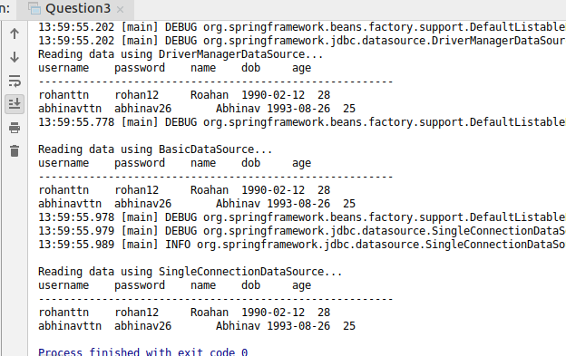

Q4. Use JdbcTemplate to get the count of users.

package com.data;
import org.springframework.beans.factory.annotation.Autowired;
import org.springframework.context.ApplicationContext;
import org.springframework.context.support.ClassPathXmlApplicationContext;
import org.springframework.jdbc.core.JdbcTemplate;
import org.springframework.stereotype.Repository;

public class Question4 {

public static void main(String[] args) {

ApplicationContext ctx = new ClassPathXmlApplicationContext("config.xml");
UserDao userDao = ctx.getBean(UserDao.class);
userDao.userCount();
}
}

@Repository
class UserDao {

private final JdbcTemplate jdbcTemplate;

@Autowired
public UserDao(JdbcTemplate jdbcTemplate) {
this.jdbcTemplate = jdbcTemplate;
}

void userCount() {
String sql = "SELECT COUNT(*) FROM USER";
System.out.println("Number of users: " + jdbcTemplate.queryForObject(sql, Integer.class));
}
}

config.xml

<bean id="singleConnectionDataSource" class="org.springframework.jdbc.datasource.SingleConnectionDataSource">
<property name="url" value="jdbc:mysql://localhost:3306/SpringDemo"/>
<property name="driverClassName" value="com.mysql.jdbc.Driver"/>
<property name="username" value="root"/>
<property name="password" value="K96sanjeev@"/>
</bean>

<context:component-scan base-package="com.data"/>
<bean class="org.springframework.jdbc.core.JdbcTemplate">
<property name="dataSource" ref="singleConnectionDataSource"/>
</bean>
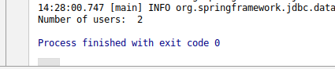

Q5. Get name of the user by providing username to the parametrized query.

package com.data;
import org.springframework.beans.factory.annotation.Autowired;
import org.springframework.context.ApplicationContext;
import org.springframework.context.support.ClassPathXmlApplicationContext;
import org.springframework.jdbc.core.JdbcTemplate;
import org.springframework.stereotype.Repository;

public class Question5 {

public static void main(String[] args) {
ApplicationContext ctx = new ClassPathXmlApplicationContext("config.xml");
GetUser getUser = ctx.getBean("getUser", GetUser.class);
System.out.println("User Name: "+getUser.getUserName("rohanttn"));
}
}

@Repository
class GetUser {

private final
JdbcTemplate jdbcTemplate;

@Autowired
public GetUser(JdbcTemplate jdbcTemplate) {
this.jdbcTemplate = jdbcTemplate;
}

Object getUserName(String name) {
String sql = "SELECT name FROM USER WHERE username = ?";
return jdbcTemplate.queryForObject(sql, new Object[]{name}, String.class);
}
}

config.xml

<bean id="singleConnectionDataSource" class="org.springframework.jdbc.datasource.SingleConnectionDataSource">
<property name="url" value="jdbc:mysql://localhost:3306/SpringDemo"/>
<property name="driverClassName" value="com.mysql.jdbc.Driver"/>
<property name="username" value="root"/>
<property name="password" value="K96sanjeev@"/>
</bean>

<context:component-scan base-package="com.data"/>
<bean class="org.springframework.jdbc.core.JdbcTemplate">
<property name="dataSource" ref="singleConnectionDataSource"/>
</bean>

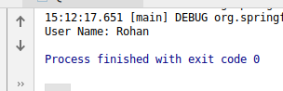

Q6. Insert one record using JdbcTemplate

package com.data;
import org.springframework.beans.factory.annotation.Autowired;
import org.springframework.context.ApplicationContext;
import org.springframework.context.support.ClassPathXmlApplicationContext;
import org.springframework.jdbc.core.JdbcTemplate;
import org.springframework.stereotype.Repository;
import javax.persistence.Entity;
import javax.persistence.Id;

public class Question6 {

public static void main(String[] args) {

ApplicationContext ctx = new ClassPathXmlApplicationContext("config.xml");
RecordInsert recordInsert = ctx.getBean(RecordInsert.class);
recordInsert.insertUser(new USER("rehanttn", "rehan14", "Rehan", "1994-09-14", 24));
}
}

@Entity
class USER {
@Id
private String userName;
private String password;
private String name;
private String dob;
private int age;

public USER(String userName, String password, String name, String dob, int age) {
this.userName = userName;
this.password = password;
this.name = name;
this.dob = dob;
this.age = age;
}

String getUserName() {
return userName;
}

String getPassword() {
return password;
}

String getName() {
return name;
}

String getDob() {
return dob;
}

int getAge() {
return age;
}
@Override
public String toString() {
return "USER{" +
"userName='" + userName + '\'' +
", password='" + password + '\'' +
", name='" + name + '\'' +
", dob='" + dob + '\'' +
", age=" + age +
'}';
}
}

@Repository
class RecordInsert {

private final
JdbcTemplate jdbcTemplate;

@Autowired
public RecordInsert(JdbcTemplate jdbcTemplate) {
this.jdbcTemplate = jdbcTemplate;
}

void insertUser(USER user) {
System.out.println("Record inserting....");
String sql = "INSERT INTO USER (username,password,name,age,dob)VALUES(?,?,?,?,?)";
jdbcTemplate.update(sql, new Object[]{
user.getUserName(), user.getPassword(), user.getName(), user.getAge(), user.getDob()
});
System.out.println("Record inserted....");
}
}

config.xml

<bean id="singleConnectionDataSource" class="org.springframework.jdbc.datasource.SingleConnectionDataSource">
<property name="url" value="jdbc:mysql://localhost:3306/SpringDemo"/>
<property name="driverClassName" value="com.mysql.jdbc.Driver"/>
<property name="username" value="root"/>
<property name="password" value="K96sanjeev@"/>
</bean>

<context:component-scan base-package="com.data"/>
<bean class="org.springframework.jdbc.core.JdbcTemplate">
<property name="dataSource" ref="singleConnectionDataSource"/>
</bean>
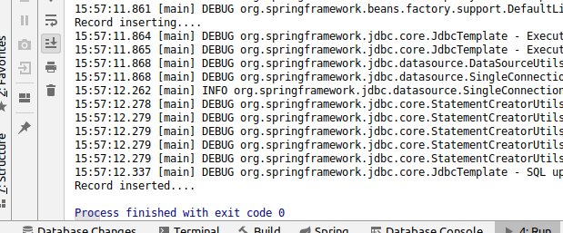

Q7. Use QueryForMap to fetch the user details of the user.

package com.data;
import org.springframework.beans.factory.annotation.Autowired;
import org.springframework.context.ApplicationContext;
import org.springframework.context.support.ClassPathXmlApplicationContext;
import org.springframework.jdbc.core.JdbcTemplate;
import org.springframework.stereotype.Repository;

public class Question7 {

public static void main(String[] args) {
ApplicationContext ctx = new ClassPathXmlApplicationContext("config.xml");
FetchQueryForMap fetchQueryForMap = ctx.getBean(FetchQueryForMap.class);
fetchQueryForMap.display("Rehan");
}
}

@Repository
class FetchQueryForMap{

@Autowired
JdbcTemplate jdbcTemplate;

void display(String name) {
String sql = "SELECT * FROM USER WHERE name = ?";
System.out.println(jdbcTemplate.queryForMap(sql, new Object[]{name}));
}
}

config.xml

<bean id="singleConnectionDataSource" class="org.springframework.jdbc.datasource.SingleConnectionDataSource">
<property name="url" value="jdbc:mysql://localhost:3306/SpringDemo"/>
<property name="driverClassName" value="com.mysql.jdbc.Driver"/>
<property name="username" value="root"/>
<property name="password" value="K96sanjeev@"/>
</bean>

<context:component-scan base-package="com.data"/>
<bean class="org.springframework.jdbc.core.JdbcTemplate">
<property name="dataSource" ref="singleConnectionDataSource"/>
</bean>
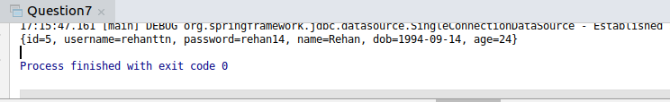

Q8. Use QueryForList to fetch records of all users

package com.data;
import org.springframework.beans.factory.annotation.Autowired;
import org.springframework.context.ApplicationContext;
import org.springframework.context.support.ClassPathXmlApplicationContext;
import org.springframework.jdbc.core.JdbcTemplate;
import org.springframework.stereotype.Repository;

public class Question8 {

public static void main(String[] args) {
ApplicationContext ctx = new ClassPathXmlApplicationContext("config.xml");
FetchQueryForList fetchQueryForList = ctx.getBean(FetchQueryForList.class);
fetchQueryForList.displayRecord();
}
}

@Repository
class FetchQueryForList {

private final JdbcTemplate jdbcTemplate;
@Autowired
public FetchQueryForList(JdbcTemplate jdbcTemplate) {
this.jdbcTemplate = jdbcTemplate;
}
void displayRecord() {
String sql = "SELECT * FROM USER";
System.out.println(jdbcTemplate.queryForList(sql));
}
}

config.xml

<bean id="singleConnectionDataSource" class="org.springframework.jdbc.datasource.SingleConnectionDataSource">
<property name="url" value="jdbc:mysql://localhost:3306/SpringDemo"/>
<property name="driverClassName" value="com.mysql.jdbc.Driver"/>
<property name="username" value="root"/>
<property name="password" value="K96sanjeev@"/>
</bean>

<context:component-scan base-package="com.data"/>
<bean class="org.springframework.jdbc.core.JdbcTemplate">
<property name="dataSource" ref="singleConnectionDataSource"/>
</bean>
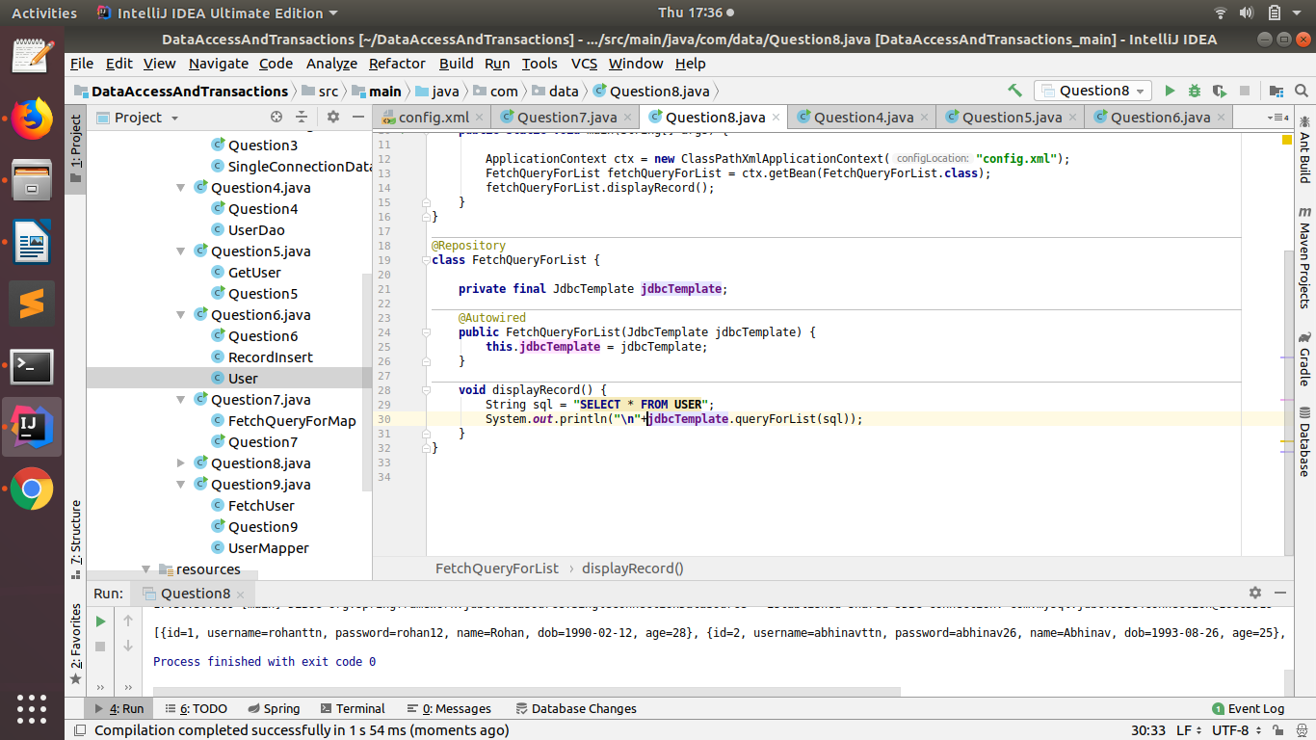

Q9. Use a rowmapper to get the User object when you query for a user

package com.data;
import org.springframework.beans.factory.annotation.Autowired;
import org.springframework.context.ApplicationContext;
import org.springframework.context.support.ClassPathXmlApplicationContext;
import org.springframework.jdbc.core.JdbcTemplate;
import org.springframework.jdbc.core.RowMapper;
import org.springframework.stereotype.Repository;
import java.sql.ResultSet;
import java.sql.SQLException;

public class Question9 {

public static void main(String[] args) {
ApplicationContext ctx = new ClassPathXmlApplicationContext("config.xml");
FetchUser fetchUser = ctx.getBean(FetchUser.class);
System.out.println(fetchUser.getUser("Rehan"));
}
}
class UserMapper implements RowMapper<User> {
@Override
public User mapRow(ResultSet rs, int rowNum) throws SQLException {
return new User(rs.getString("username"), rs.getString("password"),
rs.getString("name"), rs.getDate("dob").toString(), rs.getInt("age"));
}
}

@Repository
class FetchUser {

private final JdbcTemplate jdbcTemplate;
@Autowired

public FetchUser(JdbcTemplate jdbcTemplate) {
this.jdbcTemplate = jdbcTemplate;
}

User getUser(String name) {
String sql = "SELECT * FROM USER WHERE name = ?";
return jdbcTemplate.queryForObject(sql, new Object[]{name}, new UserMapper());
}
}

config.xml

<bean id="singleConnectionDataSource" class="org.springframework.jdbc.datasource.SingleConnectionDataSource">
<property name="url" value="jdbc:mysql://localhost:3306/SpringDemo"/>
<property name="driverClassName" value="com.mysql.jdbc.Driver"/>
<property name="username" value="root"/>
<property name="password" value="K96sanjeev@"/>
</bean>

<context:component-scan base-package="com.data"/>
<bean class="org.springframework.jdbc.core.JdbcTemplate">
<property name="dataSource" ref="singleConnectionDataSource"/>
</bean>
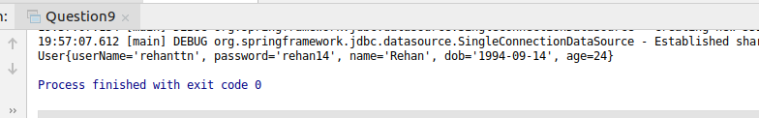

Q10. Integrate Hibernate with Spring and use hql query to count the number of records in user table.

package com.data;
import org.hibernate.SessionFactory;
import org.springframework.beans.factory.annotation.Autowired;
import org.springframework.context.ApplicationContext;
import org.springframework.context.support.ClassPathXmlApplicationContext;
import org.springframework.stereotype.Repository;

public class Question10 {

public static void main(String[] args) {
ApplicationContext ctx = new ClassPathXmlApplicationContext("config.xml");
UserDAO userDAO = ctx.getBean(UserDAO.class);
userDAO.sessionFactoryDemo();
}
}

@Repository
class UserDAO {
private final
SessionFactory sessionFactoryBean;
@Autowired
public UserDAO(SessionFactory sessionFactoryBean) {
this.sessionFactoryBean = sessionFactoryBean;
}
void sessionFactoryDemo() {
String sql = "SELECT COUNT(*) FROM USER";
org.hibernate.Query query;
query = sessionFactoryBean.openSession().createQuery(sql);
System.out.println("\nNumber of records: "+query.uniqueResult());
}
}

config.xml

<bean id="sessionFactory" class="org.springframework.orm.hibernate5.LocalSessionFactoryBean">
<property name="dataSource" ref="driverManagerDataSource"/>
<property name="packagesToScan" value="com.data"/>
<property name="hibernateProperties">
<props>
<prop key="dialect">org.hibernate.dialect.MySQLDialect</prop>
</props>
</property>
</bean>
<bean id="driverManagerDataSource" class="org.springframework.jdbc.datasource.DriverManagerDataSource">
<property name="url" value="jdbc:mysql://localhost:3306/SpringDemo"/>
<property name="driverClassName" value="com.mysql.jdbc.Driver"/>
<property name="username" value="root"/>
<property name="password" value="K96sanjeev@"/>
</bean>
<context:component-scan base-package="com.data"/>
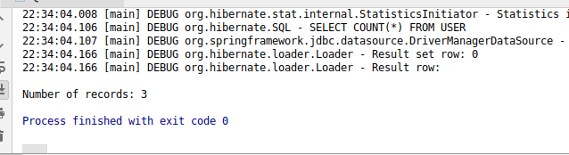

Q11. Use @Transactional to save to save 2 records using jdbc template with the following prapogation options
- REQUIRED
- REQUIRES_NEW
- NESTED
- MANDATORY
- NEVER
- NOT_SUPPORTED
- SUPPORTS

REQUIRED

UserDao1.java

package com.question11.requires_new;
import org.springframework.beans.factory.annotation.Autowired;
import org.springframework.jdbc.core.JdbcTemplate;
import org.springframework.stereotype.Repository;
import org.springframework.transaction.annotation.Propagation;
import org.springframework.transaction.annotation.Transactional;

@Repository
public class UserDao1 {
private final JdbcTemplate jdbcTemplate;
private final UserDao2 userDao2;
@Autowired
public UserDao1(JdbcTemplate jdbcTemplate, UserDao2 userDao2) {
this.jdbcTemplate = jdbcTemplate;
this.userDao2 = userDao2;
}
@Transactional(propagation = Propagation.REQUIRED)
void insertUserDao1() {
String sql = "INSERT INTO PEOPLE(id,name) VALUES (1,'Sanjeev')";
jdbcTemplate.update(sql);
try {
userDao2.insertUserDao2();
} catch (Exception ignored) {
}
}
}

UserDao2.java

package com.question11.requires_new;
import org.springframework.beans.factory.annotation.Autowired;
import org.springframework.jdbc.core.JdbcTemplate;
import org.springframework.stereotype.Repository;
import org.springframework.transaction.annotation.Propagation;
import org.springframework.transaction.annotation.Transactional;

@Repository
public class UserDao2 {

private final JdbcTemplate jdbcTemplate;
@Autowired
public UserDao2(JdbcTemplate jdbcTemplate) {
this.jdbcTemplate = jdbcTemplate;
}
@Transactional(propagation = Propagation.REQUIRED)
void insertUserDao2() {
String sql = "INSERT INTO PEOPLE(id,name) VALUES (2,'Pankaj')";
jdbcTemplate.update(sql);
throw new RuntimeException();
}
}

Main.java

package com.question11.requires_new;
import org.springframework.context.ApplicationContext;
import org.springframework.context.support.ClassPathXmlApplicationContext;

public class Main {

public static void main(String[] args) {
ApplicationContext ctx = new ClassPathXmlApplicationContext("config.xml");
UserDao1 userDao1 = ctx.getBean(UserDao1.class);
userDao1.insertUserDao1();
}
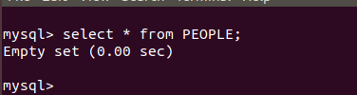
}

REQUIRES_NEW

package com.question11;
import org.springframework.beans.factory.annotation.Autowired;
import org.springframework.context.ApplicationContext;
import org.springframework.context.support.ClassPathXmlApplicationContext;
import org.springframework.jdbc.core.JdbcTemplate;
import org.springframework.stereotype.Repository;
import org.springframework.transaction.annotation.Propagation;
import org.springframework.transaction.annotation.Transactional;

public class RequiresNewTransaction {

public static void main(String[] args) {
ApplicationContext ctx = new ClassPathXmlApplicationContext("config.xml");
UserDaoRequiresNew1 userDaoRequiresNew1 = ctx.getBean(UserDaoRequiresNew1.class);
userDaoRequiresNew1.insert();
}
}

@Repository
class UserDaoRequiresNew1 {

private final
JdbcTemplate jdbcTemplate;
private final
UserDaoNested2 userDaoRequiresNew2;

@Autowired
public UserDaoRequiresNew1(JdbcTemplate jdbcTemplate, UserDaoNested2 userDaoRequiresNew2) {
this.jdbcTemplate = jdbcTemplate;
this.userDaoRequiresNew2 = userDaoRequiresNew2;
}

@Transactional(propagation = Propagation.REQUIRED)
public void insert() {
jdbcTemplate.update("INSERT INTO PEOPLE(id,name) VALUES (1,'Sanjeev')");
try {
userDaoRequiresNew2.insert();
} catch (Exception e) {
System.out.println("exception");
}
}
}

@Repository
class UserDaoRequiresNew2 {

private final JdbcTemplate jdbcTemplate;

@Autowired
public UserDaoRequiresNew2(JdbcTemplate jdbcTemplate) {
this.jdbcTemplate = jdbcTemplate;
}

@Transactional(propagation = Propagation.REQUIRES_NEW)
public void insert() {
jdbcTemplate.update("INSERT INTO PEOPLE(id,name) VALUES (2,'Aman')");
throw new RuntimeException();
}
}
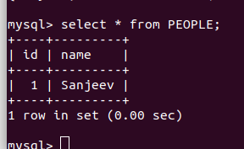

NESTED

package com.question11;
import org.springframework.beans.factory.annotation.Autowired;
import org.springframework.context.ApplicationContext;
import org.springframework.context.support.ClassPathXmlApplicationContext;
import org.springframework.jdbc.core.JdbcTemplate;
import org.springframework.stereotype.Repository;
import org.springframework.transaction.annotation.Propagation;
import org.springframework.transaction.annotation.Transactional;

public class NestedTransaction {

public static void main(String[] args) {
ApplicationContext ctx = new ClassPathXmlApplicationContext("config.xml");
UserDaoNested1 userDaoNested1 = ctx.getBean(UserDaoNested1.class);
userDaoNested1.insert();
}
}

@Repository
class UserDaoNested1 {
private final
JdbcTemplate jdbcTemplate;
private final
UserDaoNested2 userDaoNested2;

@Autowired
public UserDaoNested1(JdbcTemplate jdbcTemplate, UserDaoNested2 userDaoRequiresNew2) {
this.jdbcTemplate = jdbcTemplate;
this.userDaoNested2 = userDaoRequiresNew2;
}

@Transactional
public void insert() {
jdbcTemplate.update("INSERT INTO PEOPLE(id,name) VALUES (1,'Sanjeev')");
try {
userDaoNested2.insert();
} catch (Exception e) {
System.out.println("exception");
}
}
}

@Repository
class UserDaoNested2 {

private final JdbcTemplate jdbcTemplate;

@Autowired
public UserDaoNested2(JdbcTemplate jdbcTemplate) {
this.jdbcTemplate = jdbcTemplate;
}

@Transactional(propagation = Propagation.NESTED)
public void insert() {
jdbcTemplate.update("INSERT INTO PEOPLE(id,name) VALUES (2,'Aman')");
throw new RuntimeException();
}
}

MANDATORY

package com.question11;
import org.springframework.beans.factory.annotation.Autowired;
import org.springframework.context.ApplicationContext;
import org.springframework.context.support.ClassPathXmlApplicationContext;
import org.springframework.jdbc.core.JdbcTemplate;
import org.springframework.stereotype.Repository;
import org.springframework.transaction.annotation.Propagation;
import org.springframework.transaction.annotation.Transactional;

public class MandatoryTransaction {
public static void main(String[] args) {
ApplicationContext ctx = new ClassPathXmlApplicationContext("config.xml");
UserDaoMandatory1 userDaoMandatory1 = ctx.getBean(UserDaoMandatory1.class);
userDaoMandatory1.insert();
}
}

@Repository
class UserDaoMandatory1 {

private final
JdbcTemplate jdbcTemplate;
private final
UserDaoMandatory2 userDaoMandatory2;

@Autowired
public UserDaoMandatory1(JdbcTemplate jdbcTemplate, UserDaoMandatory2 userDaoMandatory2) {
this.jdbcTemplate = jdbcTemplate;
this.userDaoMandatory2 = userDaoMandatory2;
}

@Transactional(propagation = Propagation.REQUIRED)
public void insert() {
jdbcTemplate.update("INSERT INTO PEOPLE(id,name) VALUES (1,'Sanjeev')");
try {
userDaoMandatory2.insert();
} catch (Exception e) {
System.out.println("exception");
}
}
}

@Repository
class UserDaoMandatory2 {

private final JdbcTemplate jdbcTemplate;
@Autowired

public UserDaoMandatory2(JdbcTemplate jdbcTemplate) {
this.jdbcTemplate = jdbcTemplate;
}

@Transactional(propagation = Propagation.MANDATORY)
public void insert() {
jdbcTemplate.update("INSERT INTO PEOPLE(id,name) VALUES (2,'Aman')");
}
}
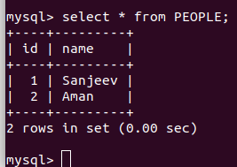

NEVER

package com.question11;
import org.springframework.beans.factory.annotation.Autowired;
import org.springframework.context.ApplicationContext;
import org.springframework.context.support.ClassPathXmlApplicationContext;
import org.springframework.jdbc.core.JdbcTemplate;
import org.springframework.stereotype.Repository;
import org.springframework.transaction.annotation.Propagation;
import org.springframework.transaction.annotation.Transactional;

public class PropagationNever {

public static void main(String[] args) {

ApplicationContext ctx = new ClassPathXmlApplicationContext("config.xml");
UserDaoNever1 userDaoNever1 = ctx.getBean(UserDaoNever1.class);
userDaoNever1.insert();
}
}

@Repository
class UserDaoNever1 {

private final
JdbcTemplate jdbcTemplate;
private final
UserDaoNever2 userDaoNever2;

@Autowired
public UserDaoNever1(JdbcTemplate jdbcTemplate, UserDaoNever2 userDaoNever2) {
this.jdbcTemplate = jdbcTemplate;
this.userDaoNever2 = userDaoNever2;
}

@Transactional(propagation = Propagation.REQUIRED)
public void insert() {
jdbcTemplate.update("INSERT INTO PEOPLE(id,name) VALUES (1,'Sanjeev')");
try {
userDaoNever2.insert();
} catch (Exception e) {
System.out.println("exception");
}
}
}

@Repository
class UserDaoNever2 {

private final JdbcTemplate jdbcTemplate;

@Autowired
public UserDaoNever2(JdbcTemplate jdbcTemplate) {
this.jdbcTemplate = jdbcTemplate;
}

@Transactional(propagation = Propagation.NEVER)
public void insert() {
jdbcTemplate.update("INSERT INTO PEOPLE(id,name) VALUES (2,'Aman')");
throw new RuntimeException();
}
}

NOT_SUPPORTED

package com.question11;
import org.springframework.beans.factory.annotation.Autowired;
import org.springframework.context.ApplicationContext;
import org.springframework.context.support.ClassPathXmlApplicationContext;
import org.springframework.jdbc.core.JdbcTemplate;
import org.springframework.stereotype.Repository;
import org.springframework.transaction.annotation.Propagation;
import org.springframework.transaction.annotation.Transactional;

public class PropagationNotSupported {

public static void main(String[] args) {
ApplicationContext ctx = new ClassPathXmlApplicationContext("config.xml");
UserDaoNotSupported1 userDaoNotSupported1 = ctx.getBean(UserDaoNotSupported1.class);
userDaoNotSupported1.insert();
}
}

@Repository
class UserDaoNotSupported1 {

private final
JdbcTemplate jdbcTemplate;
private final UserDaoNotSupported2 userDaoNotSupported2;

@Autowired
public UserDaoNotSupported1(JdbcTemplate jdbcTemplate, UserDaoNotSupported2 userDaoNotSupported2) {
this.jdbcTemplate = jdbcTemplate;
this.userDaoNotSupported2 = userDaoNotSupported2;
}

@Transactional(propagation = Propagation.REQUIRED)
void insert() {
jdbcTemplate.update("INSERT INTO PEOPLE(id,name) VALUES (1,'Sanjeev')");
try {
userDaoNotSupported2.insert();
} catch (Exception e) {
System.out.println("exception");
}
}
}

@Repository
class UserDaoNotSupported2 {

private final JdbcTemplate jdbcTemplate;

@Autowired
public UserDaoNotSupported2(JdbcTemplate jdbcTemplate) {
this.jdbcTemplate = jdbcTemplate;
}

@Transactional(propagation = Propagation.NOT_SUPPORTED)
void insert() {
jdbcTemplate.update("INSERT INTO PEOPLE(id,name) VALUES (2,'Aman')");
}
}

SUPPORTS

package com.question11;
import org.springframework.beans.factory.annotation.Autowired;
import org.springframework.context.ApplicationContext;
import org.springframework.context.support.ClassPathXmlApplicationContext;
import org.springframework.jdbc.core.JdbcTemplate;
import org.springframework.stereotype.Repository;
import org.springframework.transaction.annotation.Propagation;
import org.springframework.transaction.annotation.Transactional;

public class PropagationSupports {

public static void main(String[] args) {
ApplicationContext ctx = new ClassPathXmlApplicationContext("config.xml");
UserDaoSupports1 userDaoSupports1 = ctx.getBean(UserDaoSupports1.class);
userDaoSupports1.insert();
}
}

@Repository
class UserDaoSupports1 {

private final
JdbcTemplate jdbcTemplate;
private final UserDaoSupports2 userDaoSupports2;

@Autowired
public UserDaoSupports1(JdbcTemplate jdbcTemplate, UserDaoSupports2 userDaoNotSupported2) {
this.jdbcTemplate = jdbcTemplate;
this.userDaoSupports2 = userDaoNotSupported2;
}

@Transactional(propagation = Propagation.REQUIRED)
void insert() {
jdbcTemplate.update("INSERT INTO PEOPLE(id,name) VALUES (1,'Sanjeev')");
try {
userDaoSupports2.insert();
} catch (Exception e) {
System.out.println("exception");
}
}
}

@Repository
class UserDaoSupports2 {

private final JdbcTemplate jdbcTemplate;

@Autowired
public UserDaoSupports2(JdbcTemplate jdbcTemplate) {
this.jdbcTemplate = jdbcTemplate;
}

@Transactional(propagation = Propagation.SUPPORTS)
void insert() {
jdbcTemplate.update("INSERT INTO PEOPLE(id,name) VALUES (2,'Aman')");

}
}

config.xml
<bean id="singleConnectionDataSource" class="org.springframework.jdbc.datasource.SingleConnectionDataSource">
<property name="url" value="jdbc:mysql://localhost:3306/SpringDemo"/>
<property name="driverClassName" value="com.mysql.jdbc.Driver"/>
<property name="username" value="root"/>
<property name="password" value="K96sanjeev@"/>
</bean>
<bean id="txManager" class="org.springframework.jdbc.datasource.DataSourceTransactionManager">
<property name="dataSource" ref="singleConnectionDataSource"/>
</bean>

<tx:annotation-driven transaction-manager="txManager"/>

<context:component-scan base-package="com.question11"/>

Q12. Demonstrate the use of following options of @Transactional annotation
- read-only
- timeout
- rollback-for
- no-rollback-for
read-only
package com.question12;
import org.springframework.beans.factory.annotation.Autowired;
import org.springframework.context.ApplicationContext;
import org.springframework.context.support.ClassPathXmlApplicationContext;
import org.springframework.jdbc.core.JdbcTemplate;
import org.springframework.stereotype.Repository;
import org.springframework.transaction.annotation.Transactional;

public class ReadOnlyTransaction {

public static void main(String[] args) {
ApplicationContext ctx = new ClassPathXmlApplicationContext("config.xml");
ReadOnly1 readOnly1 = ctx.getBean(ReadOnly1.class);
readOnly1.insert();
}
}

@Repository
class ReadOnly1 {

@Autowired
JdbcTemplate jdbcTemplate;
@Autowired
ReadOnly2 readOnly2;

@Transactional
void insert() {
jdbcTemplate.update("INSERT INTO PEOPLE(id,name) VALUES (1,'Sanjeev')");
try {
readOnly2.insert();
} catch (Exception e) {
System.out.println("exception");
}
}
}

@Repository
class ReadOnly2 {

@Autowired
JdbcTemplate jdbcTemplate;

@Transactional(readOnly = true)
void insert() {
jdbcTemplate.update("INSERT INTO PEOPLE(id,name) VALUES (1,'Sanjeev')");
}
}

timeout

package com.question12;
import org.springframework.beans.factory.annotation.Autowired;
import org.springframework.context.ApplicationContext;
import org.springframework.context.support.ClassPathXmlApplicationContext;
import org.springframework.jdbc.core.JdbcTemplate;
import org.springframework.stereotype.Repository;
import org.springframework.transaction.annotation.Propagation;
import org.springframework.transaction.annotation.Transactional;

public class TimeoutTransaction {

public static void main(String[] args) {
ApplicationContext ctx = new ClassPathXmlApplicationContext("config.xml");
Timeout1 timeout1 = ctx.getBean(Timeout1.class);
timeout1.insert();
}
}

@Repository
class Timeout1{

@Autowired
JdbcTemplate jdbcTemplate;

@Transactional(propagation = Propagation.REQUIRED,timeout = 2)
public void insert() {
try {
Thread.sleep(2000L);
} catch (InterruptedException e) {
//e.printStackTrace();
}
String sql = "INSERT INTO PEOPLE(id,name)VALUES(3,'Vineet')";
jdbcTemplate.update(sql);
}
}

rollback-for

package com.question12;
import org.springframework.beans.factory.annotation.Autowired;
import org.springframework.context.ApplicationContext;
import org.springframework.context.support.ClassPathXmlApplicationContext;
import org.springframework.jdbc.core.JdbcTemplate;
import org.springframework.stereotype.Repository;
import org.springframework.transaction.annotation.Transactional;

public class RollbackForTransaction {

public static void main(String[] args) {
ApplicationContext ctx = new ClassPathXmlApplicationContext("config.xml");
RollBackFor rollBackFor = ctx.getBean(RollBackFor.class);
rollBackFor.insert();
}
}

@Repository
class RollBackFor {

@Autowired
JdbcTemplate jdbcTemplate;

@Transactional(rollbackFor = ArithmeticException.class)
public void insert() {
String sql = "INSERT INTO PEOPLE(id,name)VALUES(3,'Vineet')";
jdbcTemplate.update(sql);
int i = 1 / 0;
System.out.println(i);

}
}

no-rollback-for

package com.question12;
import org.springframework.beans.factory.annotation.Autowired;
import org.springframework.context.ApplicationContext;
import org.springframework.context.support.ClassPathXmlApplicationContext;
import org.springframework.jdbc.core.JdbcTemplate;
import org.springframework.stereotype.Repository;
import org.springframework.transaction.annotation.Transactional;

public class NoRollbackForTransaction {

public static void main(String[] args) {
ApplicationContext ctx = new ClassPathXmlApplicationContext("config.xml");
NoRollback noRollback = ctx.getBean(NoRollback.class);
noRollback.insert();
}
}

@Repository
class NoRollback{

@Autowired
JdbcTemplate jdbcTemplate;

@Transactional(noRollbackFor = ArithmeticException.class)
public void insert() {
String sql = "INSERT INTO PEOPLE(id,name)VALUES(3,'Vineet')";
jdbcTemplate.update(sql);
int i=1/0;
System.out.println(i);
}
}

